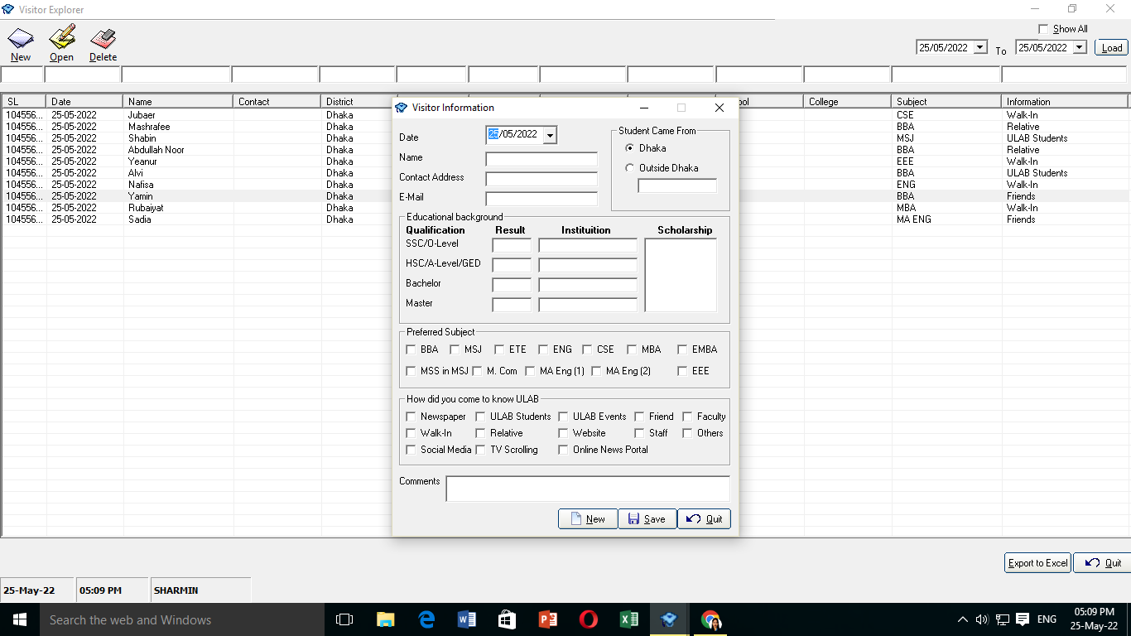

In Preferred Subject Add this two Subject

1. BA in Bang

2. BA in BLJ

In how did you come to know ULAB add this

* ULAB Flyer